Couleur :

rgba(255,255,255,0.3) / #ffffff

#d45500

#03b4e0

#007e9e

#0b5da0d8

#f9f9f9 (gris)

**#66ff66**

Black

Police:

Rockwell (extra bold)

Calisto MT

Photo:

[2976215.png (128×128)](https://cdn-icons-png.flaticon.com/128/2976/2976215.png)

[User Login Icon PNG Transparent Background, Free Download #3048 - FreeIconsPNG](https://www.freeiconspng.com/img/3048)



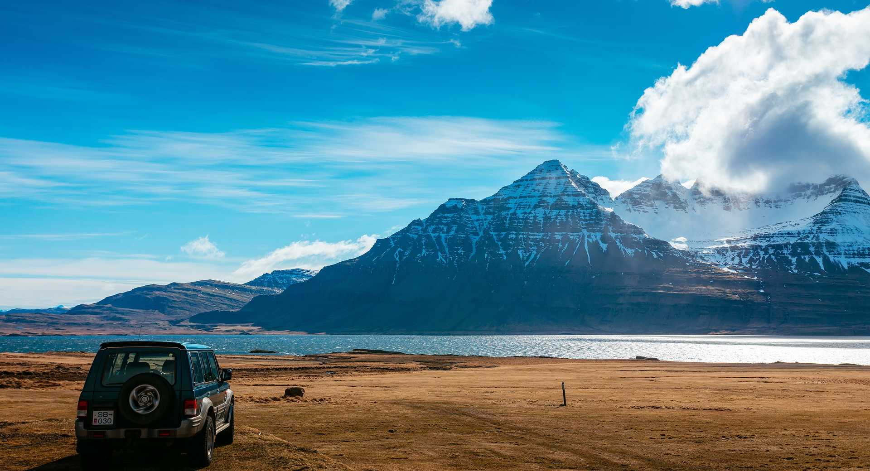

[roadtrip-en-islande-115.jpg (1920×1040)](https://photos.altai-travel.com/1920x1040/roadtrip-en-islande-115.jpg)



<https://www.evasionsgourmandes.com/wp-content/uploads/2015/10/conseils-road-trip.jpg>